**Keying chart for Gujarati WinScript**

|  |  |  |  |  |  |  |
| --- | --- | --- | --- | --- | --- | --- |
| અ | આ | ઇ | ઈ | ઉ | ઊ | ઋ |
| a | A | i | I | u | U | R |
| એ | ઐ | ઓ | ઔ | અં | અઁ | અ: |
| e | E | o | O | aM | aS | a: |
| ક | કા | કિ | કી | કુ | કૂ | કૃ |
| k | kA | ki | kI | ku | kU | kR |
| કે | કૈ | કો | કૌ | કં | કઁ | ક: |
| ke | kE | ko | kO | kM | kS | k: |
| ક | ખ | ગ | ઘ | ઙ |  |  |
| k | K | g | G | W |  |  |
| ચ | છ | જ | ઝ | ઞ | ન્ય | જ઼ |
| c | C | j | J | w | nxy | jq |
| ટ | ઠ | ડ | ઢ | ણ | ડ઼ | ઢ઼ |
| f | F | [ | { | N | [q | {q |
| ત | થ | દ | ધ | ન | દ્વ | ત્ત |
| t | T | d | D | n | dxv | txt |
| પ | ફ | બ | ભ | મ | પ્પ | બ્બ |
| p | P | b | B | m | pxp | bxb |
| ય | ર | લ | વ | ષ | રુ રૂ | ર્ક |
| y | r | l | v | Z | ru rU | rxk |
| શ | સ | હ | ક્ષ | ત્ર | જ્ઞ | ક્ર |
| z | s | h | kxZ | txr | jxw | kxr |
| ફ઼ | ઍ | ઑ | ળ | ઌ | ૡ |  |
| Pq | ] | } | L | | | _ |  |

**Conjunct characters:**

A simple conjunct is typed by pressing x between the consonants. e.g. n x n 🡪 ન્ન

A joined conjunct is typed by pressing x x between the consonants. e.g. n x x n 🡪 ન્‍ન

A non-joined conjunct is typed by pressing shift x between the consonants. e.g. n shift x n 🡪 ન્‌ન

*Alternative*: To change one type of conjunct to another, press the backtick ` key after it.

e.g. ન્ન ` 🡪 ન્‍ન ` 🡪 ન્‌ન

**Dependent/Independent Vowels:**

The keyboard will normally produce independent vowels, except after consonants, when it will produce independent vowels.

e.g. i 🡪 ઇ g i 🡪 ગિ

To force an independent vowel after a consonant, press a after the consonant.

e.g. g a i 🡪 ગઇ

*Alternative*: To change one type of vowel to the other, press the backtick ` key after it.

e.g. ગઇ ` 🡪 ગિ ` 🡪 ગઇ

Alternate forms:

In addition to altering conjuncts and vowels, the backtick ` key can produce changes like these:

e.g. ૪ ` 🡪 4 toggle digits: script ⬄ roman

**Alternate characters:**

Various related characters can be obtained by pressing the same key again without pausing.

e.g. n 🡪 ન n 🡪 ણ n 🡪 ઞ n 🡪 ઙ

If you actually want a sequence of the character, either pause or press a in between.

e.g. n n 🡪 ણ n a n 🡪 નન

**Smart Quotes:**

Press the single quote ' or double quote " key again to switch between left and right smart quotes. e.g. “ " 🡪 ”

**Brackets:**

Press the open or close parenthesis key up to 3 more times to obtain alternative forms of bracketing.

e.g. ( ( 🡪 [ ( 🡪 { ( 🡪 ⌊

**Note to Advanced Users:**

If you need an independent ZWJ or ZWNJ character (very rare), type space followed by x or shift x respectively.

**Gujarati WinScript Layout**

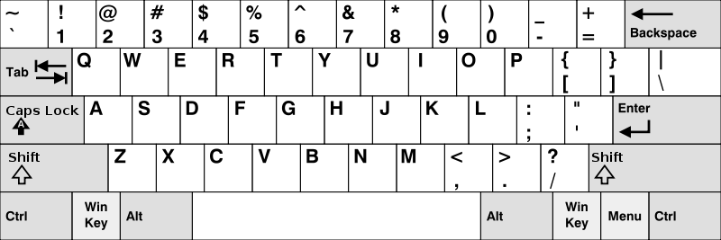

**ૡ**

**૦**

**૯**

**૮**

**૭**

**૬**

**૫**

**૪**

**૩**

**૨**

**૧**

**ઑ**

**ઍ**

**ઔ**

**થ**

**ઋ**

**ઐ**

**ઙ**

**ઊ**

**ઈ**

**ઌ**

**\**

**ઢ**

**ડ**

**ફ**

**પ**

**઼**

**ઓ**

**આ**

**ં**

**୍**

**મ**

**ણ**

**ન**

**બ**

**ભ**

**વ**

**છ**

**ચ**

**શ**

**ષ**

**અ**

**ય**

**ત**

**ર**

**એ**

**ઞ**

**ઉ**

**ઇ**

**ળ**

**લ**

**ખ**

**ક**

**ઝ**

**જ**

**ઃ**

**હ**

**ઘ**

**ગ**

**સ**

**ધ**

**દ**

**ઠટ**

**ઁ**